Assignment 02
Artificial Intelligence – AI 2101

Announced Date: April 15, 2026 | Due Date: April 27, 2026 | Total Marks = 20
Instructor Name: Mr. Hamid Ashfaq |  | Marks Obtained =

[CLO2, C3]
Consider a two-player game represented by the following game tree, where players take turns as MAX and MIN:
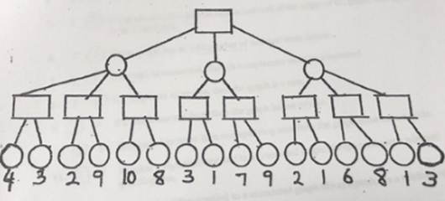
- The root node is a MAX node.
- The tree has three levels (MAX → MIN → MAX → Terminal nodes).
- The terminal node values are given at the leaf nodes.
Students are required to evaluate the game tree using search algorithms.
Tasks:
- Apply the Minimax algorithm to compute the optimal value of the root node. Show all intermediate steps.
- Apply the Alpha-Beta Pruning algorithm (from left to right) on the same tree:
- Show the values of α (alpha) and β (beta) at each step.
- Clearly indicate which branches are pruned during the process.

- Compare the performance of both algorithms:
- Count the total number of nodes evaluated using Minimax.
- Count the total number of nodes evaluated using Alpha-Beta Pruning.
- Briefly explain the difference.

Note: Submit a word document having question 1 to 3.

